# Algorithm for file updates in Python

## Project description

We want to parse a file containing IP addresses that are allowed to access restricted content and remove addresses that no longer have access.

## Open the file that contains the allow list

First, we have a files called “allow_list.txt” that has all of the allowed ip addresses, so we need to read that file using the “with .. as :” statement to ensure the file is closed after we finish from it, the open() function takes 2 arguments the file name and the mode, the file name is already given and the mode is what we want to do with the file which in this case we only need to read from the file so we add the ‘r’ string to the second argument.

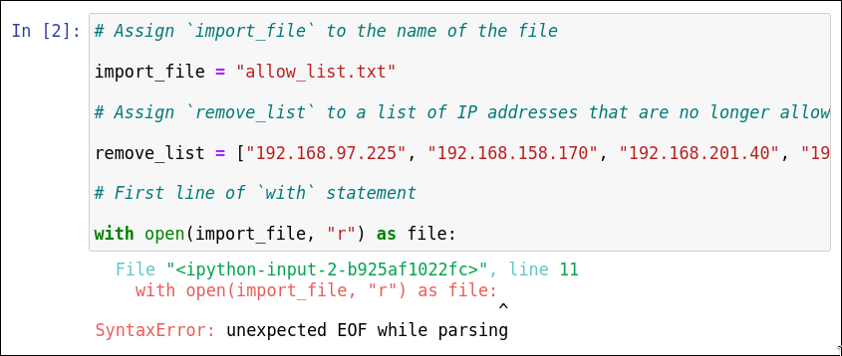

We got an error, which was expected since we didn't do anything with the file yet.

## Read the file contents

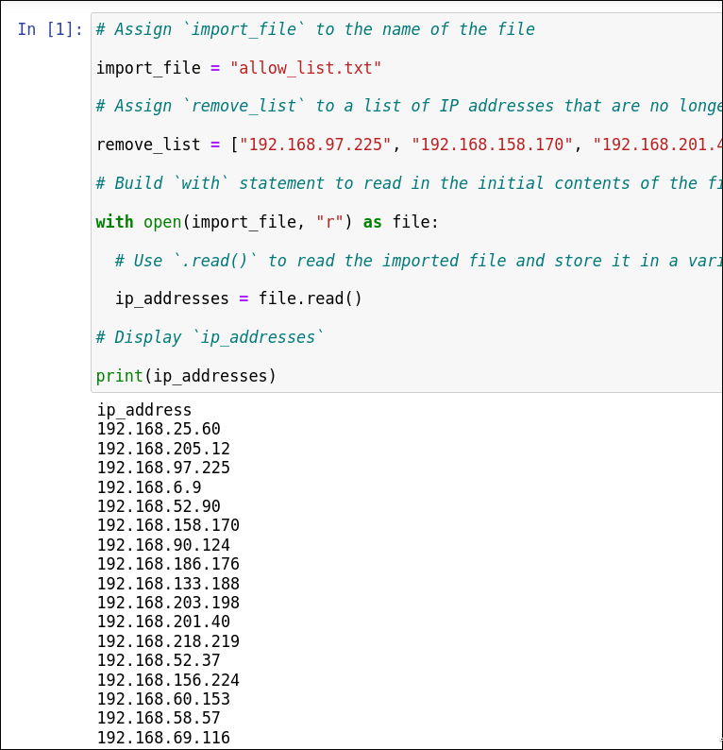

Now, we read the file content using the read() function and save it in the “ip_addresses” variable that we just made, then print it to check if it is working.

## Convert the string into a list

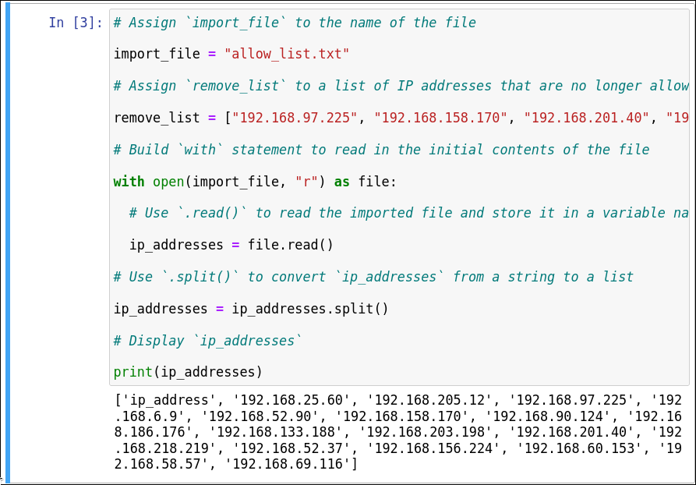

Here, we are taking that string variable “ip_addresses” and converting it into a list that we can work with in code using the “split()” function that takes the delimiter as an argument (or nothing which means “\n”) and splits the string using that delimiter.

## Iterate through the remove list

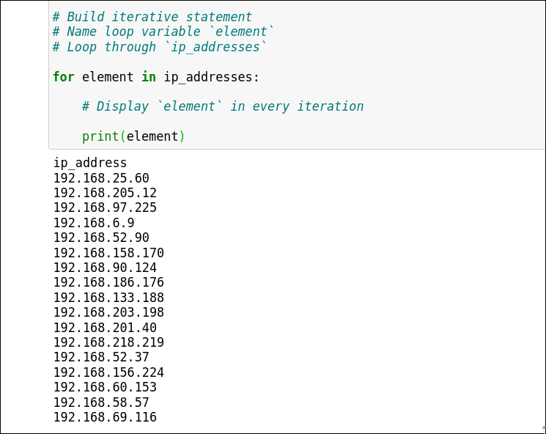

After getting the “ip_addreses” as a list we can now iterate through the list using for loop, so we can do actions on each element on that list.

## Remove IP addresses that are on the remove list

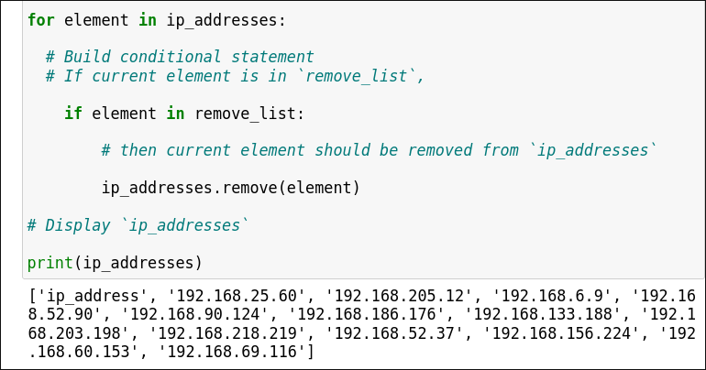

And the action that we want to do on the list is “remove()” “if” that element is “in” the “remove_list”.

## Update the file with the revised list of IP addresses

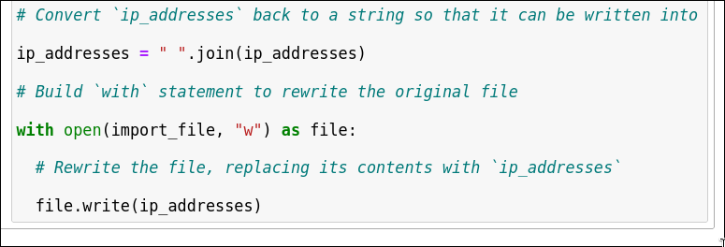

Finally, we can return our new list with the removed IP addresses into a string by using the “join()” method which we need to give a string that it is going to join with each element such as a space in our case “ “ and the prepend the “join” method with the list as an argument, and write the output to the same file “import_file” using the “w” instead of the “r”.

## Summary

In this project, we had an allow list of IP addresses for restricted content by removing those that no longer have access. We begin by opening the "allow_list.txt" file in read mode and reading its contents into the variable ip_addresses. This string is then converted into a list using the split() function. We iterate through this list, checking each IP address against a remove_list, and use the remove() method to delete any addresses found in the remove_list. Finally, we convert the updated list back into a string with the join() method and write it back to the same file in write mode, ensuring that only valid IP addresses remain in the allow list.